Find the rectangle with the largest area that can be placed inside the region bounded between the curve $y = 4 – 2x$, the horizontal axis $y = 0$ and the vertical axis $x=0$.

1) Get your data. From this I can see that I need to maximize the area and that we are bounded both in how far down we can go, $y=0$ and how far up we can go, $y=4-2x$.
- Maximize area of a rectangle
- Can’t go below $y = 0$
- Can’t go above $y=4-2x$

2) Define the variables. I know I need to find the area of a rectangle, and the area of a rectangle is given by length multiplied by height. So my variables are
- Area
- Length
- Height

3) Draw a picture
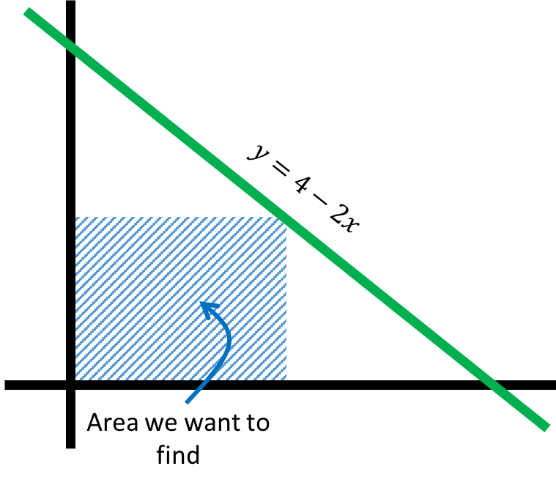
4) Determine your object function. We are trying to maximize the area. So my object function needs to calculate area.
- Area = length $×$ height

5) Fill in our object function with variables. Here I take the variable I defined in step 2 and give them letters. Then I use these letters to rewrite our object function from part 4.
- $A=l×h$

6) Find any constraints.
I know we are bounded below by $y=0$, so our height cannot be negative. I also know, from our picture in part 3, that we are bounded above by $y=4-2x$. So the height of our rectangle is given by that same function.
I also know that we are bounded to the right by the y-axis (this is assumed) and that we are bounded by the point where $y=4-2x$ crosses the $x$-axis. Since we are bounded by the y-axis on the left, the length of our rectangle is going to just be our x-value.
- $h=4-2x$
- $l=x$

7) Rewrite our objective function so we only have one variable.
- $A=l×h$
- $A=\left(4-2x\right)×x$
- $A=4x-2x^{2}$
We only have one variable so we can proceed to step 8. If we didn’t have one variable, we would have to check our constraints again and our object function to make sure they are correct.
8) Take the derivative to find the maximum or minimum.
- $A^{'}=4-4x$
- $4-4x=0$
- $x=1$
- Plug 1 into the object function to find area (1,2)
So our solution is that x = 1 gives us an area of 2 units².

9) Check if your answer makes sense
- 2 units² seems to make sense. It’s not negative area and I can somewhat visualize this rectangle in the picture we drew. So I’m content that this makes sense.

Answer: The rectangle with the largest area has an area of 2 units².

Imagine that you have just been given a vacation home situated on an island 10 miles off the coast. The nearest town is 60 miles up the coast. Every month, you must travel into town to restock your supplies. Naturally, you have an amphibious auto. It travels 30 mph in water and 55 mph along the coastal highway. Find the route that is the quickest (shortest time) to the nearest town.

1) Get the data. The last sentence tells me I am trying to minimize time. From the picture I can see that I have two different travel portions of my trip (travel on water and travel on land). So to calculate my time I am going to need to know how long I spend travelling in water and how long I spend travelling on land. I also see that I have some speed information for both water and land. Finally, I see that I have to move 10 miles “down” and 60 miles “over” to arrive at the town.
- Minimize time travelled
- Travel time in water
- Travel time in land
- 30 mph in water
- 55 mph on highway
- 10 miles up and 60 miles over

2) Define the variables. In simplest terms to figure out how much time it takes me to travel, I need to know two things, how long I spent travelling in the water and how long I spent travelling on land.
- Time travelled
- Time travelled in water
- Time travelled in land
To determine the time spent in water and on land, I do need to know other things, like the distance we travel and the speed we travel
- Time in water
  - Water distance
  - Speed in water
- Time on land
  - Land distance
  - Speed on land

3) Draw a picture to help visualize this:
We have how far down we need (10 miles) and how far over we need to go (60 miles).
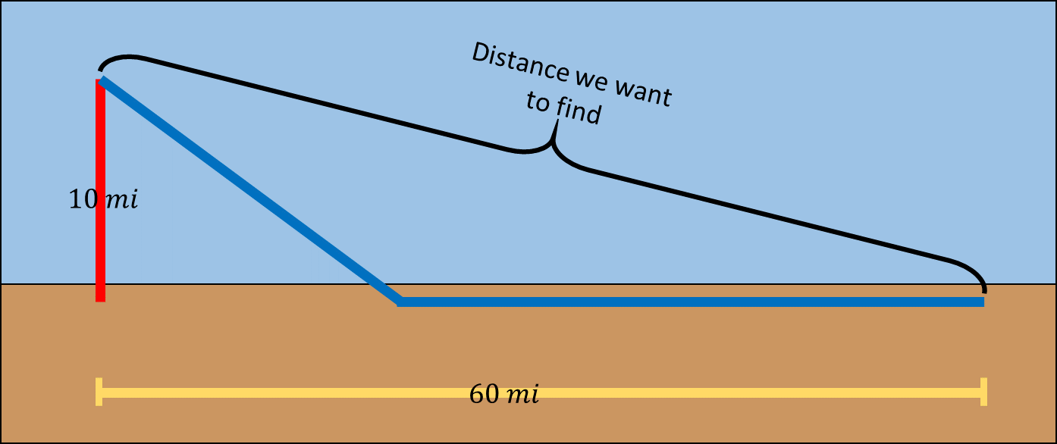

4) Determine your object function.
- Time travelled $=$ water time $+$ land time
  - Water time = $\frac{water distance}{water speed}$

  - Land time = $\frac{land distance}{land speed}$

5) Fill in your object function with variables. First, we have our simplest function which is total time travelled equals time in water plus time on land.
- $T=w+l$
Then I incorporate the other variables needed to calculate time in water and time on land. Travel time is distance divided by speed
  - $w=\frac{D_{w}}{S_{w}}$, $S_{w}=$30 mph
  - $l=\frac{D_{l}}{S_{l}}$, $S_{l}=$55 mph
Now I put everything together to see what I have in the objective function
$$T=\frac{D_{w}}{30 mph}+\frac{D_{l}}{55 mph}$$

6) Find your constraints. We don’t really have any constraints her, but we do know (at least to some degree) the path we will have to travel. So we will try to use that.
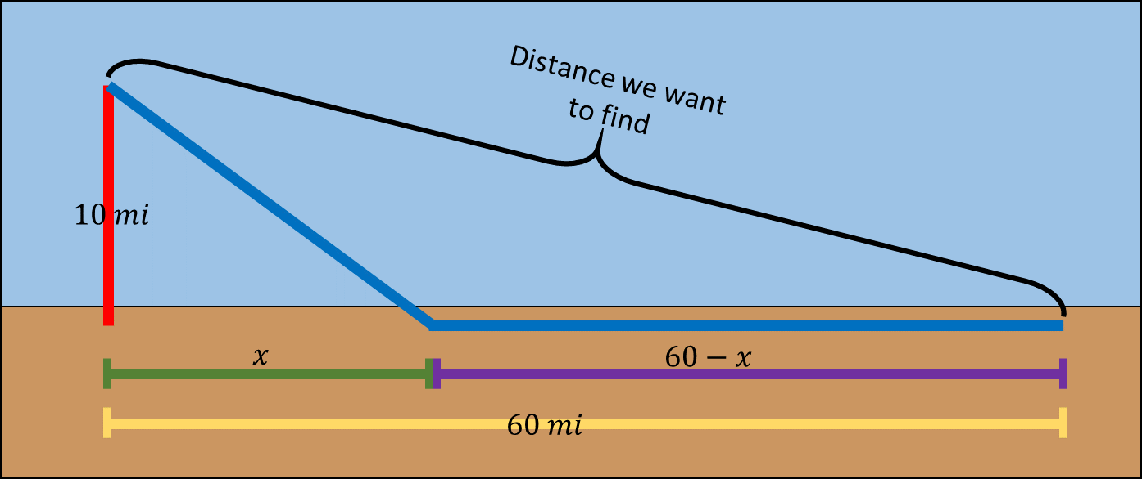
Here I split the horizontal distance (in yellow) into two sections (a green section I called X, because we don’t know this distance, and a purple section I called 60-X).
I did this because we know we have to travel some horizontal amount in the water, BUT we don’t know how far that distance will be. Thus, I called that specific distance X. Also, if we travel X miles horizontally on the water, then we will need to travel 60-X miles horizontally by land.
However, we still don’t know how far we actually travel on the water. But, at least now we know that we will go 10 miles down and X miles over.
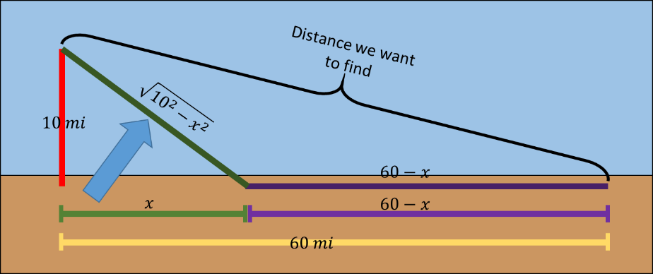
NOTE* $\sqrt{{10}^{2}-x^{2}}$ should be $\sqrt{{10}^{2}+x^{2}}$

I used the fact that 10 miles and X miles are the smaller sides of a right triangle to calculate the distance we will travel on the water $\left(\sqrt{{10}^{2}+x^{2}}\right)$. Now we know how far we will move via the water and how far we will move via the land
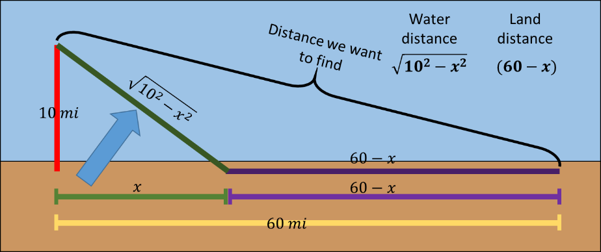
NOTE* $\sqrt{{10}^{2}-x^{2}}$ should be $\sqrt{{10}^{2}+x^{2}}$

Our water travel distance is $\left(\sqrt{{10}^{2}+x^{2}}\right)$ and our land travel distance is $60-x$

7) Rewrite your object function so you only have one variable
Our object function from above, was $$T=\frac{D_{w}}{30 mph}+\frac{D_{l}}{55 mph}$$
Now we have our water distance and our land distance so we can fill those in
$$T=\frac{\sqrt{{10}^{2}+x^{2}}}{30 mph}+\frac{60-x}{55 mph}$$

CHECK: does this have only one variable?
Yes, it only has the variable X.
So, that means we can take the derivative now.

8) Take the derivative to find the maximum or minimum
The derivative is
- $T^{'}=\frac{x}{30\sqrt{100+x^{2}}}-\frac{1}{55}$
Set this equal to zero and solve
- $T^{'}=\frac{x}{30\sqrt{100+x^{2}}}-\frac{1}{55}=0$
- $x≈ 6.5$

- Now we know exactly how long $x$ is. With this, we have our route.
- We will need to travel $\left(\sqrt{100+{6.5}^{2}}=11.9\right)$11.9 miles by water and we will need to travel $\left(60-6.5=53.5\right)$ 53.5 miles by land
- 11.9 miles by water and 53.5 miles by land

9) Check if your answer makes sense
- Our answer makes sense because we don’t have any negative distance and nothing over 60. So it seems good to me

In a simple model of territory, a single animal defends a circular territory of radius x (miles). The following assumptions are made:
- The energy L spent per day in looking for food and defending the territory is directly proportional to the area of the region.
- The energy G gained per day is directly proportional to the radius x.
Suppose that L = 3000 calories and G = 3500 calories when x = 1. Find the territorial size that will result in maximum benefit to the animal, that is, maximize the net energy G − L.

1) Get the data. The last sentence tells me I am trying to maximize net energy ($G-L$).
- We also know that the territory is a circle that has a radius of $x$.
- We are given two equations, one for $L$ and one for $G$
  - $L$ is proportional to area
  - $G$ is proportional to radius
- Finally, we are given some information $L = 3000$ calories and $G = 3500$ calories when $x = 1$.

2) Define the variables.
- In simplest terms to figure out my net energy (let’s call this $N$), I need $L$ and $G$.
- For $L$ and $G$ I need two constants, let’s call them $α$ and $β$.
  - (I need two constants because parts A and B describe a function that is proportional to).

3) I could draw a picture, but I think we all know what a circle looks like

4) Determine your object function.
- Object function is $N=G-L$
- I can also incorporate the other information we know about $L$ and $G$
  - $L=α\left(πx^{2}\right)$ Remember, that $L$ is proportional to area and $x$ is our radius
  - $G=βx$ Remember, that $G$ is proportional to the radius $x$

5) Fill in your object function with variables.
- Using our equations for $L$ and $G$, we have
$$N=βx-α\left(πx^{2}\right)$$

6) Find your constraints.
- There aren’t really any constraints. Nothing tells us how big or how small the size has to be, but we are given some other information that we haven’t used yet.
  - When $x=1$, $L=3000$
  - When $x=1$, $G=3500$

7) Rewrite your object function so you only have one variable
- Our object function $N=βx-α\left(πx^{2}\right)$has three variables, $α, β,$and $x$.
- So we need to use some information to rewrite these in terms of the other. The only other information we have is shown just above in part 6).
- Using the information of when $x=1$, $L=3000$, we have
  - $3000=α\left(π1^{2}\right)$
  - $3000=α(π)$
  - $\frac{3000}{π}=α$
  - So we have solved for $α$
- Using the information of when $x=1$, $G=3500$, we have
  - $3500=β1$
  - $3500=β$
  - So we have solved for $β$
- If we plug these new equations for $α$ and $β$ we can obtain

$$N= 3500x-\frac{3000}{π}\left(πx^{2}\right)$$

CHECK: does this have only one variable?
Yes, it only has the variable $x$.
So, that means we can take the derivative now.

8) Take the derivative to find the maximum or minimum
- The derivative is
$$N^{'}=3500-6000x$$
- Set this equal to zero and solve
$$N^{'}=3500-6000x=0$$
- We obtain $x=\frac{6000}{3500}≈0.58$
- A territory with a radius of 0.58 miles will maximize net energy

9) Check if your answer makes sense
- The answer makes sense because our radius is not negative and we only have one solution

